Programming Fundamentals Assignment

# Name: Khawaja Irtaza

# ID: F2023065202

# Task Number: 4

### Task:

Write a program which prompts the user to input a number and displays if its greater than 10.

### Code:

#include<iostream>

using namespace std;

int main()

{

int a;

cout << "Enter number : ";

cin >> a;

if(a==10)

{

cout << "Entered number is equal to 10";

}

else if(a>10)

{

cout << "Entered number is greater than 10";

}

else

{

cout << "Entered number is lesser than 10";

}

return 0;

}

### Output:

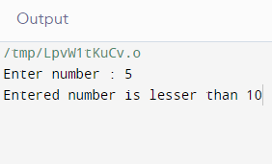

### Task:

Write a program which prompts a user to input a number and identify if it is an even number or odd number.

### Code:

#include<iostream>

using namespace std;

int main()

{

int a;

cout << "Enter number : ";

cin >> a;

if(a==10)

{

cout << "Entered number is equal to 10";

}

else if(a%2==0)

{

cout << "Entered number is even.";

}

else

{

cout << "Entered number is odd.";

}

return 0;

}

### Output:

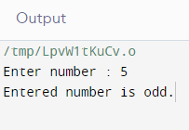

### Task:

Write a program which prompts user to input 2 numbers and then prompt user if he want to add, subtract, multiply or divide these numbers. After computing the desired action, show the result on console.

### Code:

#include <iostream>

using namespace std;

int main ()

{

float a, b, result;

int mode;

cout<<"-----MENU BASED CALCULATOR-----\n Enter 1 for sum.\n Enter 2 for subtraction.\n Enter 3 for multiplication. \n Enter 4 for division. \n Enter mode : ";

cin>>mode;

if((mode<1)||(mode>4))

{

cout<<" Invalid mode. Enter a mode between 1-4.";

}

else

{

cout<<" Enter 1st number: ";

cin>>a;

cout<<" Enter 2nd number: ";

cin>>b;

if(mode==1)

{

result=a+b;

cout<<" Result = "<<result;

}

else if(mode==2)

{

result=a-b;

cout<<"Result = "<<result;

}

else if(mode==3)

{

result=a*b;

cout<<"Result = "<<result;

}

else

{

result=a/b;

cout<<"Result = "<<result;

}

}

return 0;

}

### Output:

